**OS ASSIGNMENT 2**

2 – Batch Programs

Questions :-

1. Create a menu and display it. The user will select one of the menu

option depending on the option selected a DOS command should be executed.

Menu should contain the following:

a. List all files

b. Create directory

c. Display today’s date and time

d. Make abc.txt file as read-only

e. Exit from menu

Code :-

@echo off

@REM labeling

echo.

color a

:menu

echo ********** Menu **********

echo 1. List All Files

echo 2. Create Directory

echo 3. Display Today's Date And Time

echo 4. Make abc.txt file as read-only

echo 5. Exit from menu

echo.

set /p ch=Enter your choice:%=%

if %ch%==1 goto label-1

if %ch%==2 goto label-2

if %ch%==3 goto label-3

if %ch%==4 goto label-4

if %ch%==5 goto label-5

:label-1

echo.

dir /p

echo.

goto menu

:label-2

echo.

md new-dir

dir /ad

echo.

goto menu

:label-3

echo.

echo Date

 date /t

echo Time

time /t

echo.

goto menu

:label-4

echo.

notepad abc.txt

attrib +r .\abc.txt

echo .

echo **** Showing File Types ****

attrib

echo.

goto menu

:label-5

cls

Output :- 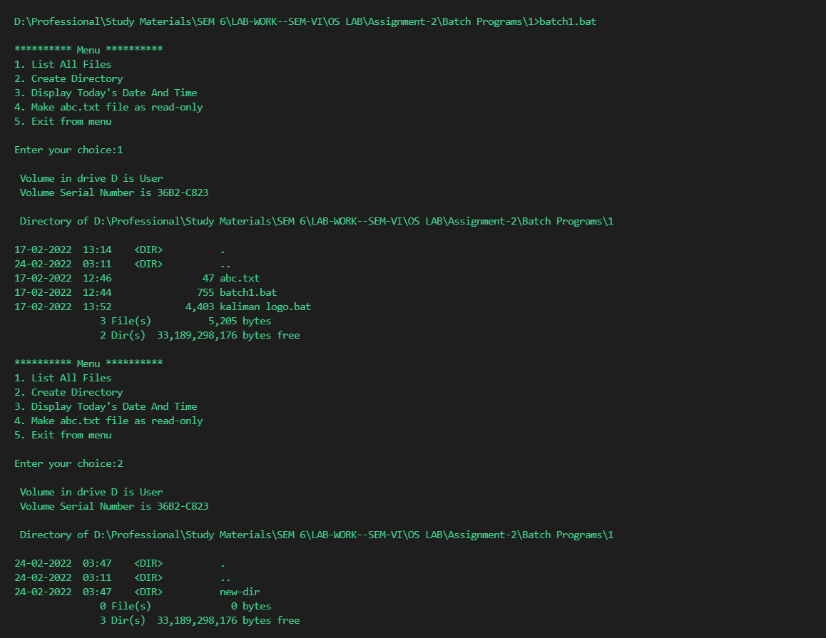 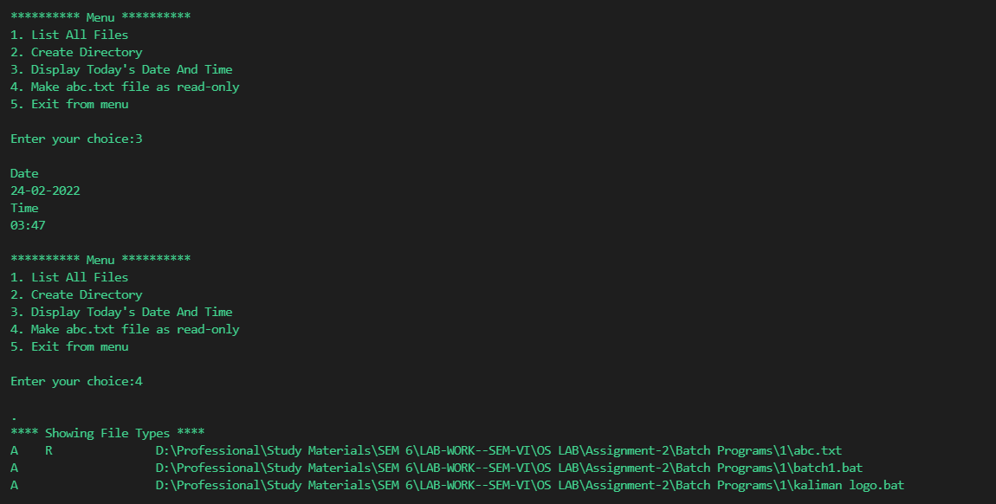

1. Execute a C language program from the batch code.

Code :-

BATCH2.BAT

@echo off

pushd

call %1

if not exist %1 call hello.exe

echo.

popd

hello.c

#include <stdio.h>

int main()

{

    printf("Hello , world called from batch file ... :)");

    return 0;

}

Output :-



1. Create an employee table in database and insert records in it. This should be done by calling the SQL script from the batch code.

Code :-

Output :-

1. Display the arithmetic table of ‘n’ (or 2). This value n should be supplied by the

user from the command prompt.

Code :-

batch4.bat

@echo off

set input=

set /p input=Enter n :

if  %input%=="" set /a input=2

for /l %%i in (1,1,10) do call arithmatic.bat %%i %input%

arithmetic.bat

@echo off

set input=

set /a input =(%1) *(%2)

echo %2 * %1 =%input%

Output :-

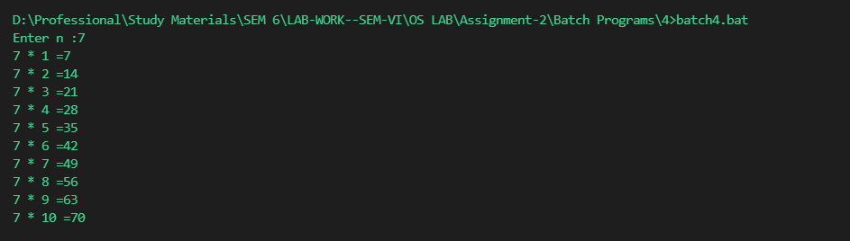

1. Call a batch program 2 from another batch program1. Batch program2 should be

creating a user usr1 and also create its home path as C:\BE32\usr1.

Code :-

Batch5-1.bat

@echo off

call batch5-2.bat

batch5-2.bat

@echo off

echo Hello From Batch5 2

echo displaying users

echo.

net user

echo crating new user BE301

echo.

net user /add BE301 smitshah

Output :-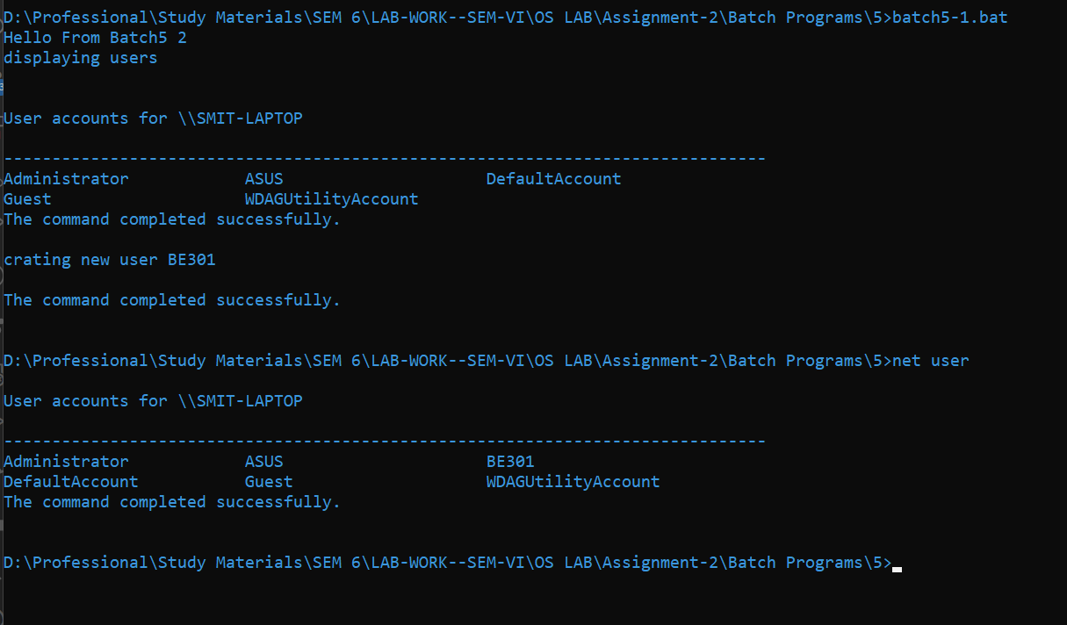

1. Copy all the .txt files from C:\D1 to three directories D:\D1, D:\D2, D:\D3.

Code :-

@echo off

:: Program to copy text files

for %%i in (1,1,3) do copy d:\temp\*.txt d:\d%%i

Output :-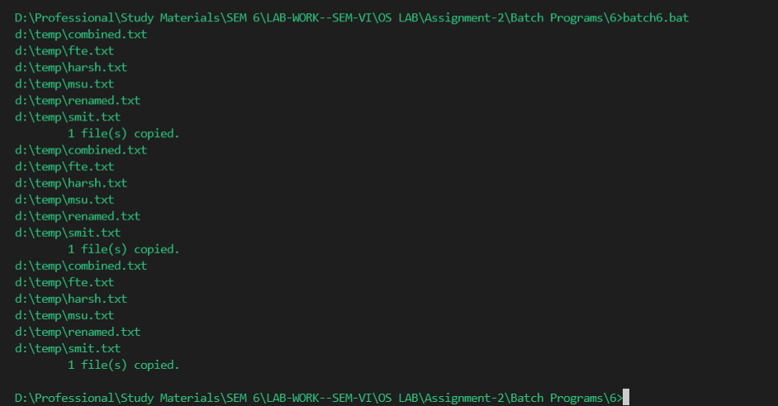

1. Your current directory is C:\D1, which contains some batch code which involves

another batch file lying in D:\D1. From batch program1 go to path of batch

program2, execute it and come back to original path.

Code :-

@echo off

@REM Program to call batch program at another location and coma back

pushd d:\temp

call c:\temp\hello.bat

popd

Output :-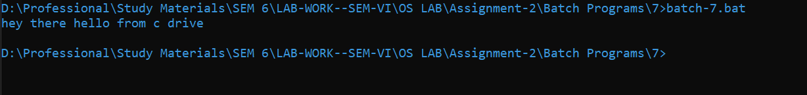

1. Execute a batch code from a C program.

Code:-

Batch8.bat

@echo off

@REM This code is being run from c program

echo you are in batch code...

call.c

#include <stdio.h>

#include<stdlib.h>

int main(){

printf("\n Running batch program from following cc code");

system("batch8.bat");

  return 0;

}

Output :-

